**Coursera Capstone Project**

IBM Applied Data Science Professional Program

*Viability of Indian Restaurant in New York City*

*By*

*Manisha Mishra*

*March 2021*

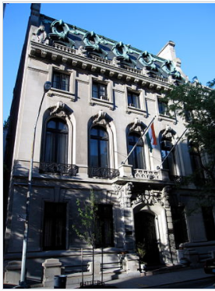

*New India House in NY city*

**Introduction:**

New York city is the most populated city in the United States and is home to one of the world’s largest and fastest growing ethnic demographics. An estimated 9 million people call it home according to 2019 U.S Census data. It’s two key demographic attributes are population density and cultural diversity. Around 36% of the city’s population are born outside of the country.

Asian Americans are a big part of the immigration population in New York city. New York contains the highest total Asian population of any U.S. city. The Indian American population in the New York City metropolitan region was second in its population as an [Asian ethnicity](https://en.wikipedia.org/wiki/Asian_people) only to the approximately 893,697 [Chinese New Yorkers](https://en.wikipedia.org/wiki/Chinese_in_New_York_City) as of 2017. There were 226,888 [Indian Americans](https://en.wikipedia.org/wiki/Indian_American) residing in the city, representing 2.7% of the population.

The graphs below represent Asian American population by ethnicity per Wikipedia 2018 census data and Indian American population by NY city boroughs per Wikipedia 2012-2014 data.

Figures presented below informs that Indian population is quite high and they are mostly concentrated in Queens area. Indian Americans have quite high median income too.

Aim of this project is to identify the best locations for Indian restaurants throughout New York city. Reviewing the Indian population in NY city and recent popularity of Indian food, setting up a new Indian restaurant can be a good and profitable plan. However, as statistics show as opening and running a successful new restaurant demands detail planning, market data analysis and solid financial planning. Accessibility to the location is another huge factor for any long-term business success. In particular, the location of the restaurant is one of the most important factors that will affect whether it will have success or a failure.

My capstone project will try to answer these two questions for an investor:

What location will be good to open a new Indian restaurant?

Where is the best Indian food available?

**Data Needed:** We will use New Your city data found at the following link:

<https://cf-courses-data.s3.us.cloud-object-storage.appdomain.cloud/IBMDeveloperSkillsNetwork-DS0701EN-SkillsNetwork/labs/newyork_data.json>

Data related to Indian restaurants will be obtained via the FourSquare API. Data for ratings, tips and likes submitted by users will be summarized and read to a DataFrame. Folio mapping tool will be used to display the density, location of the existing Indian Restaurants around the NY city boroughs.

Data will be grouped, sorted and analyzed to find which location should be new restaurant will be opened and where is the best Indian food available.

Data related to Indian restaurants will be obtained via the FourSquare API.

Limitation on data gathering is to 500 meters within the location and limit to 100 top locations

Data for ratings, tips and likes submitted by users will be summarized and read to a DataFrame.

We will use geopy library to get the latitude and longitude of the address

Folio mapping tool will be used to display the density, location of the existing Indian Restaurants around the NY city boroughs.

**Methodology:**

I have used newyork_data.json in the link provided above, to obtain New York related data (Boroughs, neighborhoods, latitudes and longitudes).

I used FourSquare API for obtaining details of Indian restaurants in New Youk city.

Matplotlib was used to plot visualizations to compare restaurants per neighborhoods and restaurants per boroughs

**Results and Discussion:**

Results are provided in graphs and data tables below.

Indian restaurants located at Manhattan has the highest average rating, likes and tips indicating that’s the best place to go for Indian food. Queens and Brooklyn tie closely for the second highest rating.

Among all neighborhoods, Tribeca in Manhattan borough has the highest rating for Indian restaurants.

Among all boroughs, Manhattan has the highest rating followed by and Staten Island as close second for Indian restaurants.

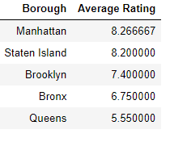

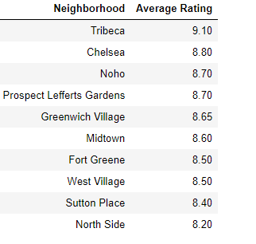

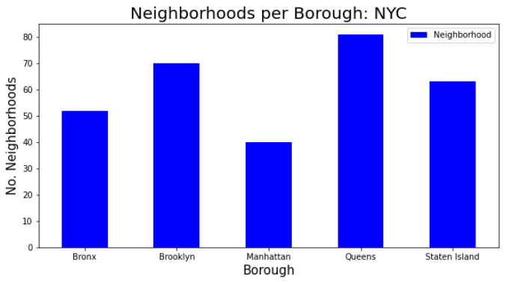

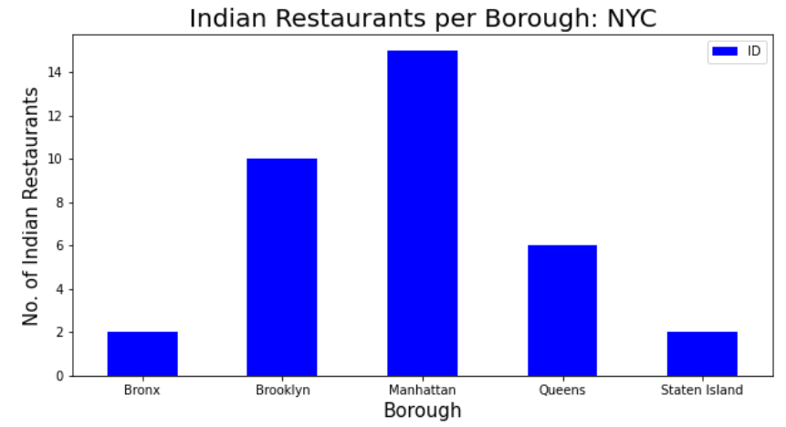

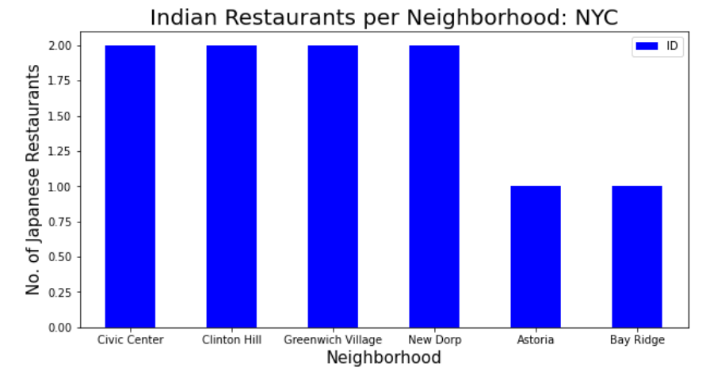

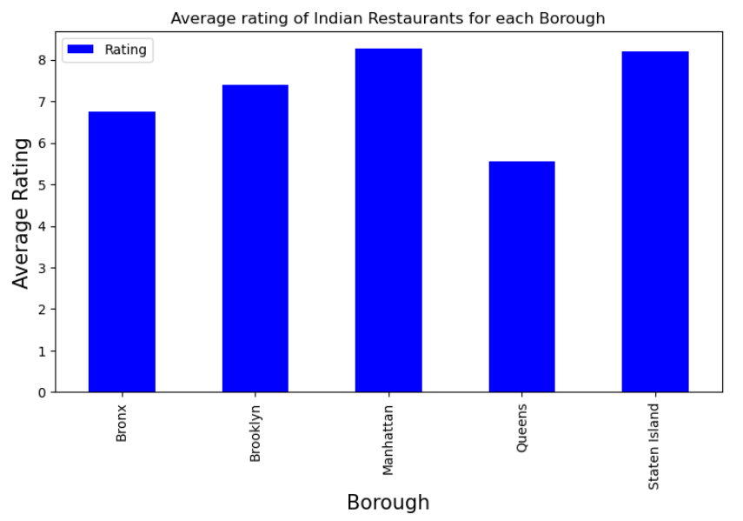

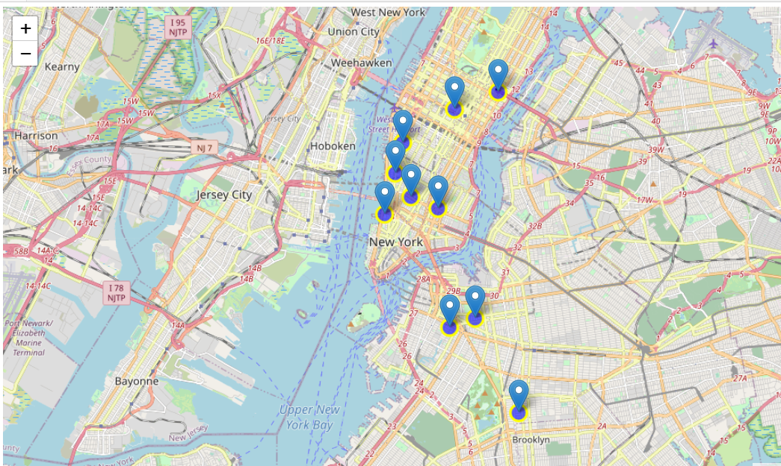

Manhattan has the highest average rating for Indian restaurants. Staten Island tie closely for the second highest rating.

Based on the data analysis, we can conclude that Manhattan and Staten Island are best locations for Indian cuisine in NY city. Opening either at Brooklyn will have equal chance of success as most Indian demographic population are closer to Brooklyn shown by the demographic research.

**Conclusions:**

In this project we have of identified a business problem, specifying the data required. Utilized several data extraction tools and methodology in extracting and preparing the data, performing data analysis, and providing recommendations to the investors/developers. Completing this project, we have applied different data science methods and tools to research and analyze the data and to find an answer to our main question: “Where is a good location in New York city to open an Indian Restaurant?” An investor can make a better decision based on the data and conclusion provided in this research.

**Limitations and challenges:** The above project research are based on the accuracy of FourSquare data. Free sandbox tier API is very restrictive and gives error after few tries. NY city census data is based on relatively older census data. More recent data will provide better demographic analysis and scope.